

National Textile University
Department of Computer Science
Subject: Operating system

Submitted to: Sir Nasir

Submitted by: Maha

Reg. number: 23-NTU-CS-1170
Lab 10 (Home task)
Semester:5th

Task1:
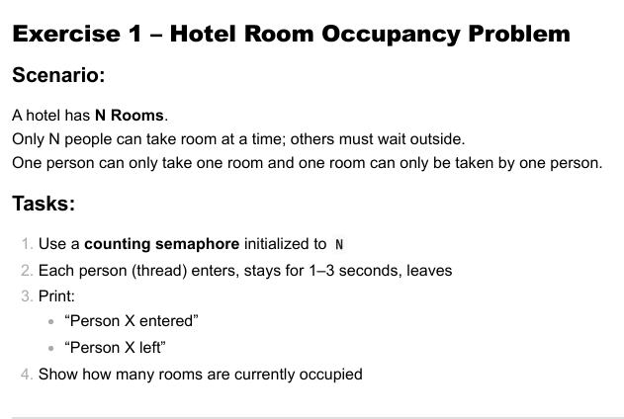
Code:
#include <stdio.h>
#include <stdlib.h>
#include <pthread.h>
#include <semaphore.h>
#include <unistd.h>
#include <time.h>

sem_t rooms; // counting semaphore
int occupied = 0; // currently occupied rooms
pthread_mutex_t lock; // protects occupied variable

void* person(void* arg) {
int id = *(int*)arg;

// wait if no room
sem_wait(&rooms);

// critical section (entering)
pthread_mutex_lock(&lock);
occupied++;
printf("Person %d entered | Occupied rooms: %d\n", id, occupied);
pthread_mutex_unlock(&lock);

// stay 1–3 seconds
sleep((rand() % 3) + 1);

// critical section (leaving)
pthread_mutex_lock(&lock);
occupied--;
printf("Person %d left | Occupied rooms: %d\n", id, occupied);
pthread_mutex_unlock(&lock);

// release a room
sem_post(&rooms);

pthread_exit(NULL);
}

int main() {
srand(time(NULL));

int N = 3; // total rooms
int people = 10; // total threads

pthread_t threads[people];
int ids[people];

sem_init(&rooms, 0, N); // initialize semaphore to N rooms
pthread_mutex_init(&lock, NULL);

// create threads
for (int i = 0; i < people; i++) {
ids[i] = i + 1;
pthread_create(&threads[i], NULL, person, &ids[i]);
}

// wait for all
for (int i = 0; i < people; i++) {
pthread_join(threads[i], NULL);
}

sem_destroy(&rooms);
pthread_mutex_destroy(&lock);

return 0;
}

Terminal:
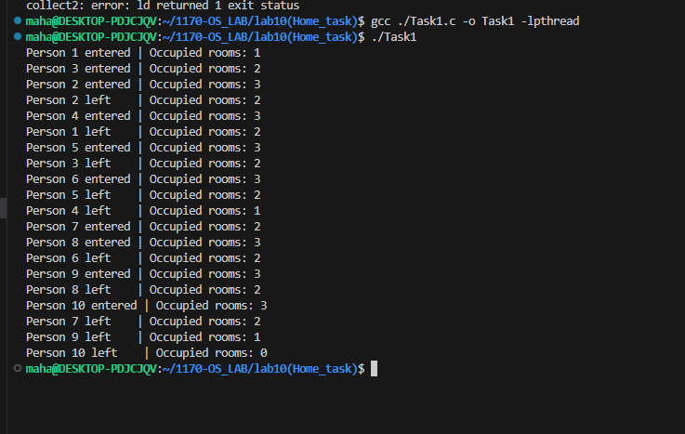
Reminders:
- Uses a counting semaphore to limit how many threads (people) can enter the hotel rooms at the same time.
- Each thread enters, prints a message, stays for 1–3 seconds, and then leaves.
- A mutex lock protects the shared occupied counter to avoid race conditions during printing.
- Ensures that at most N rooms are occupied at any moment, accurately simulating hotel room allocation.
Task2:
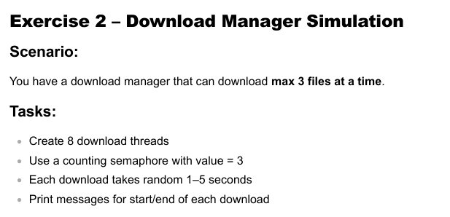
Code:
#include <stdio.h>
#include <stdlib.h>
#include <pthread.h>
#include <semaphore.h>
#include <unistd.h>
#include <time.h>

sem_t downloadSlots;

void* downloadFile(void* arg) {
int id = *(int*)arg;

sem_wait(&downloadSlots);
printf("Download %d STARTED\n", id);

sleep((rand() % 5) + 1); // 1–5 sec

printf("Download %d FINISHED\n", id);
sem_post(&downloadSlots);

return NULL;
}

int main() {
srand(time(NULL));
pthread_t t[8];
int ids[8];

sem_init(&downloadSlots, 0, 3);

for (int i = 0; i < 8; i++) {
ids[i] = i + 1;
pthread_create(&t[i], NULL, downloadFile, &ids[i]);
}
for (int i = 0; i < 8; i++) pthread_join(t[i], NULL);

sem_destroy(&downloadSlots);
return 0;
}

Terminal:
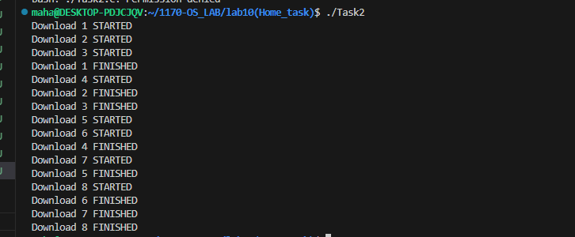
Reminder:
- Only 3 downloads allowed at once (counting semaphore = 3).
- 8 threads simulate 8 file downloads.
- Each download lasts 1–5 seconds.
Task3:
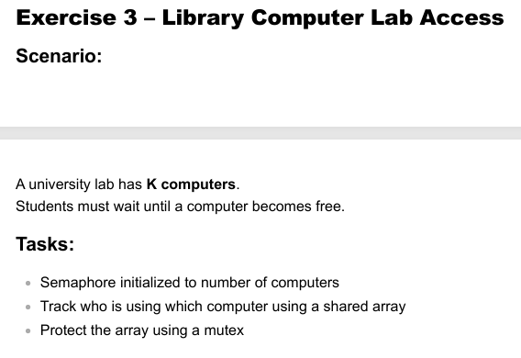
Code:
#include <stdio.h>
#include <stdlib.h>
#include <pthread.h>
#include <semaphore.h>
#include <unistd.h>

sem_t computers;
pthread_mutex_t lock;
int compUse[5]; // K = 5 computers

void* student(void* arg) {
int id = *(int*)arg;

sem_wait(&computers);

pthread_mutex_lock(&lock);
int assigned = -1;
for (int i = 0; i < 5; i++) {
if (compUse[i] == 0) {
compUse[i] = id;
assigned = i;
break;
}
}
printf("Student %d using computer %d\n", id, assigned);
pthread_mutex_unlock(&lock);

sleep(2);

pthread_mutex_lock(&lock);
compUse[assigned] = 0;
printf("Student %d left computer %d\n", id, assigned);
pthread_mutex_unlock(&lock);

sem_post(&computers);
return NULL;
}

int main() {
pthread_t s[10];
int ids[10];

sem_init(&computers, 0, 5);
pthread_mutex_init(&lock, NULL);

for (int i = 0; i < 5; i++) compUse[i] = 0;

for (int i = 0; i < 10; i++) {
ids[i] = i + 1;
pthread_create(&s[i], NULL, student, &ids[i]);
}
for (int i = 0; i < 10; i++) pthread_join(s[i], NULL);

return 0;
}
Terminal:
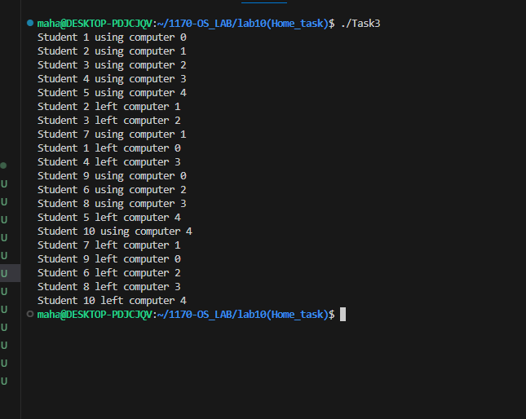
Reminder:
- Semaphore = number of computers (5).
- Shared array tracks which student is on which computer.
- Mutex protects the computer assignment array.

Task4:
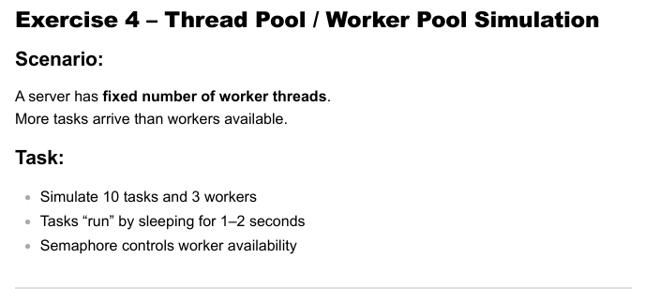
Code:
#include <stdio.h>
#include <stdlib.h>
#include <pthread.h>
#include <semaphore.h>
#include <unistd.h>

sem_t workers;

void* task(void* arg) {
int id = *(int*)arg;

sem_wait(&workers);
printf("Task %d STARTED\n", id);

sleep((rand() % 2) + 1); // 1–2 sec work

printf("Task %d FINISHED\n", id);
sem_post(&workers);

return NULL;
}

int main() {
srand(time(NULL));
pthread_t t[10];
int ids[10];

sem_init(&workers, 0, 3);

for (int i = 0; i < 10; i++) {
ids[i] = i + 1;
pthread_create(&t[i], NULL, task, &ids[i]);
}
for (int i = 0; i < 10; i++) pthread_join(t[i], NULL);

return 0;
}
Terminal:
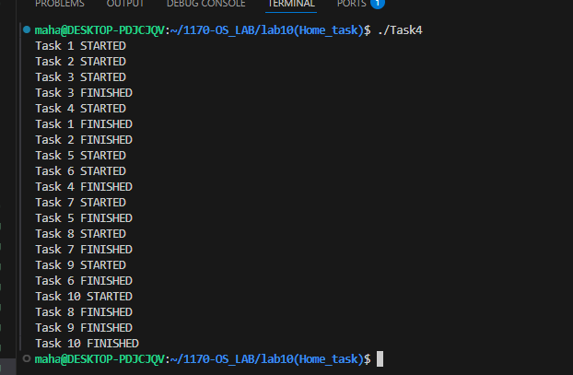
Reminder:
- Semaphore = 3 workers.
- 10 tasks compete for limited workers.
- Each task runs 1–2 seconds.
Task5:
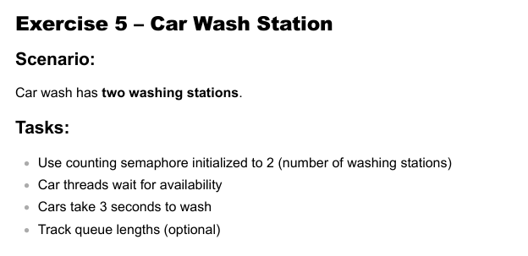
Code:
#include <stdio.h>
#include <stdlib.h>
#include <pthread.h>
#include <semaphore.h>
#include <unistd.h>

sem_t stations;

void* car(void* arg) {
int id = *(int*)arg;

sem_wait(&stations);
printf("Car %d is WASHING\n", id);

sleep(3);

printf("Car %d is DONE\n", id);
sem_post(&stations);

return NULL;
}

int main() {
pthread_t c[6];
int ids[6];

sem_init(&stations, 0, 2);

for (int i = 0; i < 6; i++) {
ids[i] = i + 1;
pthread_create(&c[i], NULL, car, &ids[i]);
}
for (int i = 0; i < 6; i++) pthread_join(c[i], NULL);

return 0;
}
Terminal:
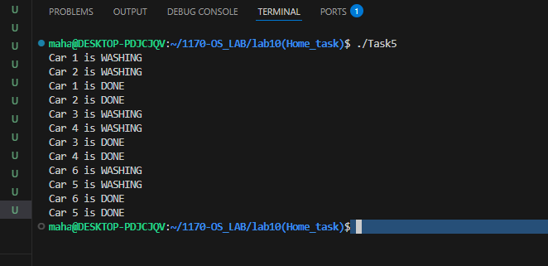
Reminder:
- Semaphore = 2 washing stations.
- Cars wait until a station becomes free.
- Wash time is 3 seconds.

Task6:
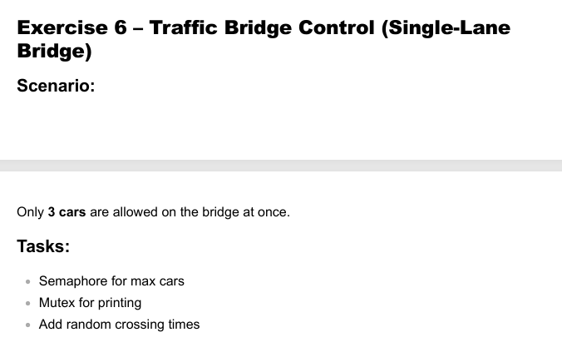
Code:
#include <stdio.h>
#include <stdlib.h>
#include <pthread.h>
#include <semaphore.h>
#include <unistd.h>

sem_t bridge;
pthread_mutex_t printLock;

void* car(void* arg) {
int id = *(int*)arg;

sem_wait(&bridge);

pthread_mutex_lock(&printLock);
printf("Car %d ENTERED bridge\n", id);
pthread_mutex_unlock(&printLock);

sleep((rand() % 3) + 1);

pthread_mutex_lock(&printLock);
printf("Car %d LEFT bridge\n", id);
pthread_mutex_unlock(&printLock);

sem_post(&bridge);

return NULL;
}

int main() {
srand(time(NULL));
pthread_t c[10];
int ids[10];

sem_init(&bridge, 0, 3);
pthread_mutex_init(&printLock, NULL);

for (int i = 0; i < 10; i++) {
ids[i] = i + 1;
pthread_create(&c[i], NULL, car, &ids[i]);
}
for (int i = 0; i < 10; i++) pthread_join(c[i], NULL);

return 0;
}
Terminal:
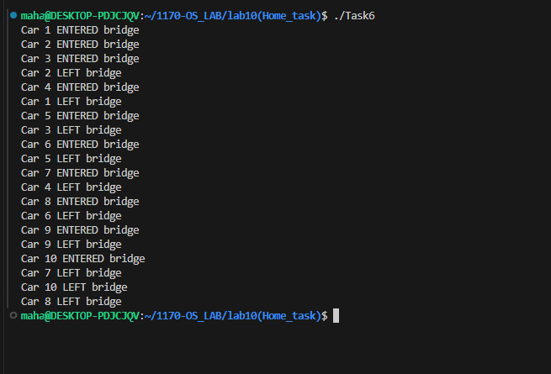
Reminder:
- Only 3 cars allowed on bridge at once.
- Mutex ensures clean printing.
- Car crossing time is random (1–3 seconds).

